
E22-xxxx Series Digital Programmable DC Power Supply

User Manual

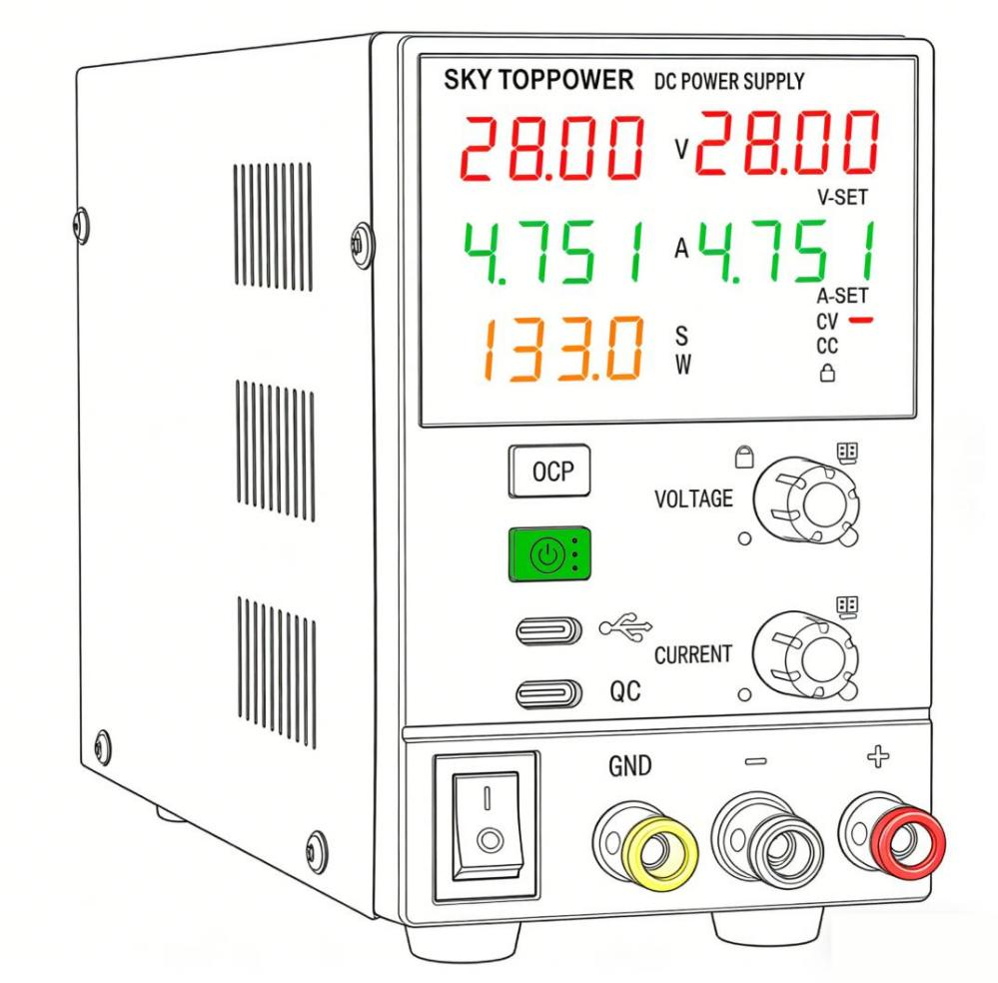
• Welcome to use SKY TOPPOWER products. Please read this manual before operating this device!
• Please keep this user manual for future reference!
• For a more detailed user manual, please contact your distributor to request the electronic version!

Contact Information
Manufacturer:Shenzhen SKY TOPPOWER Technology Co., Ltd.

Address:Room 305, Building 1, Unit 2, Runxingfa Industrial Park, No. 19 Tianbao Road, Yingrenshi Community, Shiyan Street, Bao'an District, Shenzhen

Phone:0755-23316973

Web: www.skytoppower.com

E-mail:stp@skytoppower.com；support@skytoppower.com

Table of Contents
- Important Safety Warnings
- Product Overview & Application Scope
- Full Technical Specifications
- Front & Rear Panel Layout & Component Guide
- Installation, Wiring & Pre-Power-On Inspection
- Basic Operation Guide
- Constant Voltage (CV) Mode Operation
- Constant Current (CC) Mode Operation
- Full Menu Parameter Settings
- PC Upper Computer Software & Modbus RTU Communication
- Multi-Layer Protection Mechanism (OVP/OCP/OPP/OTP)
- Practical Application Operation Cases
- Troubleshooting Guide
- Daily Maintenance & Storage Instructions
- Prohibited Usage Scenarios & High-Risk Operations
- Standard & Optional Accessories
- Manufacturer Contact & Warranty Policy

1. Important Safety Warnings

Classification of Warning Marks
⚠️ DANGER: High voltage inside the unit, risk of electric shock or fatal injury
⚠️ WARNING: Improper operation may cause permanent damage to the power supply or load
⚠️ NOTICE: Improper operation leads to abnormal output or minor functional failure

Mandatory Pre-Operation Rules
- Match the input AC voltage correctly before powering on (110V/220V wide-range input). Mismatched voltage will burn internal circuits.
- Check all wiring terminals tightly secured. Loose wiring creates high contact resistance, causing overheating and terminal melting.
- Confirm positive/negative polarity of output wiring before connecting loads. Reverse polarity will destroy the power supply instantly. For battery charging, connect a matched fuse or DC circuit breaker in series on output cables for anti-reverse protection.
- Do not touch output terminals with bare hands during operation, especially under high-voltage output status. Never operate the unit with wet hands.
- Keep at least 10cm of unobstructed ventilation space around the fan outlet. Blocked airflow triggers over-temperature protection and shortens service life.
- Non-professional technicians are strictly forbidden to open the chassis. Internal high-voltage circuits pose severe shock hazards; unauthorized disassembly voids all warranty coverage.
- This power supply is NOT suitable for electrolytic plating industry. Please select SKY TOPPOWER dedicated plating power supplies for plating applications.

Long-Term Storage Safety
Unplug the power cord if the unit will not be used for more than one month. Power the unit for a minimum of 30 minutes every 6 months to expel internal moisture.

2. Product Overview & Application Scope

2.1 Product Introduction
The E22xxxx series is a digitally controlled programmable DC power supply equipped with precision rotary encoders for voltage/current adjustment. It supports local panel operation, PC remote control via Modbus RTU protocol, and integrates multiple built-in safety protection mechanisms. Dual 4-digit displays simultaneously show preset values and real-time output values for intuitive observation. Two independent USB Type-C ports are separately designed for data communication and 18W fast charging, meeting diversified laboratory, maintenance and industrial testing demands.

2.2 Core Product Features
- Digital encoder precise adjustment: Short press to switch digit positions; rotate to modify values; long press to activate lock function.
- Dual independent Type-C ports:
- USB-C COM Port: Data communication only, requires 4-core data cable for PC connection; no charging function.
- Type-C QC Port: Independent 18W fast charging output, unaffected by main DC output parameters.
- Dual real-time display: Separate readouts for set voltage/current and actual output voltage/current; 4-digit display for voltage, current and power readings.
- Preset parameter function: Pre-set voltage and current before connecting loads, with one-click output start/stop.
- Full protection system: OVP (Over-Voltage Protection), OCP (Over-Current Protection), OPP (Over-Power Protection), OTP (Over-Temperature Protection).
- Panel lock function: Avoid accidental parameter modification caused by misoperation.
- Temperature-controlled silent cooling fan: Fan remains stationary below 60°C and accelerates rotation proportionally as temperature rises, balancing low noise and heat dissipation.
- Remote PC control: Compatible with dedicated SKY TOPPOWER upper computer software based on Modbus RTU communication protocol.（Note: For Windows systems only）

2.3 Typical Application Scenarios
Electronic equipment maintenance, laboratory R&D testing, lithium battery charging, LED lamp aging test, chip static current measurement, Electrolytic plating production,automated production line programmable power supply.

3. Full Technical Specifications
Category | Parameter Index | Detailed Description
AC Input | 110V/220V AC ±10%, 50/60Hz | Wide-range universal mains input
DC Output Voltage | DC 0 ~ Rated Value, continuously adjustable | Smooth stepless voltage regulation
DC Output Current | DC 0 ~ Rated Value, continuously adjustable | Smooth stepless current regulation
Display Resolution | Voltage: 4 digits; Current: 4 digits；Power: 4 digits | High-precision digital readout
Display Accuracy | ±0.1% ± 2 digits (based on rated value) | Small measurement deviation under full range
Readback Accuracy | ≤0.2% ± 2 digits (based on rated value) | Real-time feedback data accuracy
Source Regulation | ≤0.2% | Output fluctuation caused by mains voltage change
Voltage Load Regulation | ≤0.2% | Voltage deviation under varying load resistance
Current Load Regulation | ≤0.2% | Current deviation under varying load resistance
Ripple & Noise | ≤0.5% RMS | Low ripple for precision chip power supply
Cooling Mode | Temperature-controlled fan forced air cooling | Silent low-speed operation at low temperature
Operating Ambient | -10°C ~ 40°C, Relative Humidity < 80% | No condensation allowed
Storage Ambient | -20°C ~ 80°C, Relative Humidity < 80% | Dry, dust-free storage environment

Parameter Terminology Explanation
- Source Regulation: Voltage fluctuation when mains voltage rises or falls within the standard range. Smaller value means more stable output.
- Load Regulation: Output change when load resistance changes; critical for precision electronic testing.
- Ripple & Noise: AC interference superimposed on DC output; low ripple avoids damage to sensitive semiconductor components.

Model Naming Rule
E22-XXXX: The last four digits represent rated output voltage and rated output current of the power supply.

4. Front & Rear Panel Layout & Component Guide

4.1 Front Panel Component Definition
- Voltage Adjustment Rotary Encoder
- Short press: Switch flashing digit position for voltage setting; rotate left/right to adjust digit value.
- Long press (3s): Activate/deactivate panel LOCK lock function.
- Current Adjustment Rotary Encoder
- Short press: Switch flashing digit position for current setting; rotate left/right to adjust digit value.
- OCP Shortcut Button
- Short press under normal working mode: Quick trigger overcurrent protection test.
- Output Start/Stop & Composite Menu Button (Core Multifunction Key)
- Short press (normal mode): Turn main DC output ON / OFF.
- Short press after protection trigger: Reset OCP & OPP protection (OVP/OTP requires power cycle to reset).
- Long press (3s): Enter global menu setting mode.
- Short press (in menu): Switch to next menu item.
- Long press (3s in menu): Save modified parameters and exit menu page.
- Display Area Windows
- V-SET Window: Preset target voltage value
- V Output Window: Real-time actual output voltage
- A-SET Window: Preset target current value
- A Output Window: Real-time actual output current
- W Window: Real-time output power reading
- Status Indicator Lights
- CV Lamp (Constant Voltage): Lit = Power supply runs under constant voltage mode
- CC Lamp (Constant Current): Lit = Power supply runs under constant current mode
- LOCK Lamp: Lit = Panel buttons & encoders locked, parameter modification disabled
- OCP Lamp: Flashing/Lit = Over-current protection triggered
- Dual Type-C Ports
- USB-C COM Port: Communication port for PC software, must use 4-core data transfer Type-C cable
- Type-C QC Port: Independent 18W fast charging output port, compatible with ordinary charging cables
- Main Output Terminals: Red = Positive (+), Black = Negative (-); GND terminal for grounding connection

4.2 Rear Panel Component Definition
- AC Power Input Socket: Connect matched AC power cord
- Fuse Holder: Built-in safety fuse; replace only with fuse of identical specification
- Temperature Control Cooling Fan: Auto-adjust speed based internal temperature

Critical Distinction Table for Two Type-C Ports
Port Marking | Official Name | Core Function | Required Cable
USB-C COM Port | Communication Type-C Port | PC Modbus communication, no charging output | 4-core data transmission Type-C cable
Type-C QC Port | QC Fast Charging Port | Independent 18W charging output, unrelated to main DC output | Ordinary charging Type-C cable

5. Installation, Wiring & Pre-Power-On Inspection

5.1 Placement & Heat Dissipation Requirements
Place the unit on a flat, horizontal, stable desktop. Reserve ≥10cm empty space at the fan air outlet and side vents. Do not stack other equipment on top of the power supply; avoid covering ventilation holes with cloth or debris.

5.2 AC Input Wiring
Plug the matched standard power cord into the rear AC socket and connect to grounded 110V/220V mains socket. Ensure the ground wire of the power cord is well connected for anti-static safety.

5.3 Main DC Output Wiring Rules
- Standard Test Leads Connection: Match red lead to positive (+) terminal, black lead to negative (-) terminal; fully tighten terminal screws to eliminate loose contact.
- Long Cable Aging Test: Use thick low-resistance copper wires to reduce voltage drop during high-current output.
- Battery Charging Special Wiring: Connect a matched fuse or DC circuit breaker in series on output lines to prevent reverse polarity damage.

5.4 Five-Step Pre-Power-On Checklist (Must Complete Before Switching On)
- Confirm AC mains voltage matches the unit’s 110V/220V input range.
- Check output terminals have no short-circuit between positive and negative poles.
- Verify load wiring polarity is not reversed.
- Clear all obstructions from the rear cooling fan.
- Ensure all terminal screws are fully tightened without looseness.

6. Basic Operation Guide

6.1 Adjust Voltage & Current Precisely
- Rotate voltage/current encoder to preliminary adjust the target value.
- Short press the encoder once: one digit will flash on the display.
- Rotate the encoder left/right to increase or decrease the flashing digit.
- Short press the encoder again to switch the flashing digit position (thousands, hundreds, tens, units).
- After setting all digits, wait 2 seconds; the display stops flashing and saves preset values automatically.

6.2 Lock / Unlock Panel Operation
- Lock: Under normal display status, long press voltage encoder for 3 seconds → LOCK indicator lights up, all encoders and buttons disabled.
- Unlock: Long press voltage encoder for another 3 seconds → LOCK lamp turns off, full panel operation restored.

6.3 Set Power-On Default Output Status
- Long press composite menu button for 3s to enter menu page.
- Toggle to menu item "NO" via short pressing the menu button.
- Rotate voltage encoder to adjust parameter:
- OFF: No output automatically after powering on (recommended for safety)
- YES: Automatic DC output once the unit is powered on
- Long press menu button 3s to save settings and exit menu mode.

6.4 Cooling Fan Working Logic
Internal temperature < 60°C: Fan stops running for silent operation.
Internal temperature > 60°C: Fan auto starts; rotation speed rises synchronously with temperature. This is normal design, not equipment failure.

7. Constant Voltage (CV) Mode Operation

7.1 Mode Introduction
Constant Voltage mode maintains fixed output voltage, while output current automatically changes following load resistance. Applicable for MCU power supply, digital equipment maintenance, fixed voltage device power supply. CV indicator lamp stays lit under normal CV operation.

7.2 Operation Method 1 (Adjust Parameters After Output Activation)
- Connect AC power cord and turn on power switch.
- Short press composite menu button to activate main DC output.
- Turn current encoder to set maximum current limit.
- Adjust voltage encoder to target required voltage value.
- Connect load between red (+) and black (-) output terminals.

7.3 Operation Method 2 (Pre-Set Parameters Before Output Start, Safer for New Users)
- Power on the unit, short press menu button to cut off main output.
- Pre-set target voltage and current limit via two encoders.
- Connect load to output terminals correctly.
- Short press composite menu button once to turn on DC output.

7.4 Critical CV Mode Warning
The preset current limit value must be higher than the actual working current of your load. If the set current is lower than load demand, the unit will automatically switch to CC mode, CV lamp turns off, and output voltage drops sharply.
Example: If your load works at 3A, set current limit to 3.5A or higher.

8. Constant Current (CC) Mode Operation

8.1 Mode Introduction
Constant Current mode maintains fixed output current, while output voltage automatically adjusts with load resistance. Suitable for lithium battery charging, LED bead aging, constant-current component testing. CC indicator lamp stays lit under normal CC operation.

8.2 Operation Method 1 (Adjust Parameters After Output Activation)
- Connect AC power and turn on power switch.
- Short press menu button to activate DC output.
- Adjust voltage encoder to set voltage higher than the normal working voltage of the load.
- Rotate current encoder counterclockwise to minimum value; CC lamp lights up, output voltage drops close to 0V.
- Connect load to positive/negative terminals.
- Rotate current encoder clockwise to adjust to target constant current value.

8.3 Operation Method 2 (Pre-Set Parameters Before Output Start)
- Power on the unit, short press menu button to close main output.
- Pre-set target voltage ( higher than load working voltage) and target constant current.
- Connect load to output terminals with correct polarity.
- Short press composite menu button to enable DC output.

8.4 Critical CC Mode Warning
- Always keep CC lamp lit during constant-current operation. If CV lamp lights up, either increase preset voltage value, reduce set current, or check broken load wiring.
- Confirm your load supports constant-current operation before using CC mode.

9. Full Menu Parameter Settings

How to Enter & Exit Menu
- Enter: Long press composite menu button for 3 seconds
- Switch menu items: Short press composite menu button
- Modify parameters: Rotate voltage adjustment encoder
- Save & Exit: Long press composite menu button for 3 seconds

Complete Menu Item List & Explanation
Menu Code | Item Name | Function & Adjustable Range
NO | Power-On Output State | OFF = No output after boot; YES = Auto output after boot
OVP | Over-Voltage Protection Threshold | Set maximum allowed output voltage, auto cut-off once exceeded
OCP | Over-Current Protection Threshold | Set maximum allowed output current for overcurrent cutoff
OPP | Over-Power Protection Threshold | Set maximum output power limit for power overload protection
TEMP | OTP Over-Temperature Trigger Point | Custom internal temperature threshold for thermal shutdown
ADDR | Modbus Communication Address | 1~247, for multi-power supply parallel PC control
BAUD | Modbus Baud Rate | Serial communication speed matching upper computer software
DIM | Screen Brightness Adjustment | Adjust display screen brightness for different environments
LOCK | Auto Panel Lock Delay | Set idle time to auto-lock encoders and buttons

10. PC Upper Computer Software & Modbus RTU Communication

10.1 Software Download & Installation Steps
- Open official website: https://www.skytoppower.com
- Navigate to SUPPORT → DOCUMENT section
- Enter "REGULATED POWER SUPPLY" category
- Download "STP2S Series Power Supply Upper Computer Installation Program" and complete installation on Windows PC

10.2 Communication Connection Requirements
- Prepare a 4-core data transmission USB Type-C cable (ordinary charging cables cannot transmit data).
- Connect one end of cable to front panel USB-C COM Port, the other to PC USB port.
⚠️ Do NOT plug into Type-C QC fast charging port for communication.

10.3 PC Software Operation Steps
- Complete driver installation after software setup.
- Launch the upper computer program, select the correct COM port and matching Modbus address set on the power supply menu.
- Click "Connect Device" to establish communication link.
- Remote functions supported: One-click set voltage/current, remote output start/stop, real-time data recording, continuous aging test parameter batch editing.

10.4 Modbus RTU Protocol Note
The communication standard adopts Modbus RTU. For detailed register definitions, refer to independent document: Digital Power Supply Communication Protocol ModBusVxx.

10.5 Common Communication Failure Troubleshooting
- PC cannot recognize the unit: Use non-data charging cable / wrong Type-C port inserted / missing USB driver
- Connection failed after identification: Mismatched Modbus address or baud rate setting
- Disconnected randomly: Loose Type-C cable contact

11. Multi-Layer Protection Mechanism (OVP/OCP/OPP/OTP)

11.1 OVP Over-Voltage Protection
- Trigger Condition: Real output voltage exceeds customized OVP threshold
- Performance: Instantly cut DC output, system lock alarm
- Reset Method: Power the unit off and restart, or reset OVP value in menu

11.2 OCP Over-Current Protection
- Trigger Condition: Output current exceeds OCP limit (short circuit, overload load)
- Performance: OCP indicator lights up, output immediately shut down
- Reset Method: Short press composite start/stop menu button directly without reboot

11.3 OPP Over-Power Protection
- Trigger Condition: Output power exceeds preset OPP power limit
- Performance: Output cut off to avoid load over-power damage
- Reset Method: Short press composite menu button

11.4 OTP Over-Temperature Protection
- Trigger Condition: Internal temperature exceeds TEMP menu setting value
- Performance: All output shut down, fan runs at full speed
- Reset Method: Wait for internal temperature to drop, then restart the unit

Protection Classification Summary
One-click resettable protection: OCP, OPP
Power-cycle required protection: OVP, OTP

12. Practical Application Operation Cases

Case 1: Digital Repair CV Mode Power Supply (5V MCU Board)
- Power on, enter menu "NO" and set to OFF (no auto output).
- Pre-set V=5.000V, I=2.000A.
- Connect MCU board to output terminals with correct polarity.
- Short press menu button to activate output, CV lamp lights up.

Case 2: Single-Cell Lithium Battery CC Constant Current Charging
- Enter menu, set OVP to 4.200V to prevent overcharging.
- Switch to CC mode preset: V=5.000V, I=0.500A.
- Connect battery positive to red terminal, negative to black terminal.
- Enable output; CC lamp stays lit during charging. When battery is full, unit auto switches to CV mode and reduces charging current.

Case 3: LED Bead Constant Current Aging Test
- Set voltage 3V higher than LED rated working voltage.
- Adjust current to LED rated constant current value.
- Connect LED series load to output terminals, start output for long-term aging test.

Case 4: PC Automated Batch Aging Test
- Connect power supply to PC via 4-core data Type-C cable.
- Set Modbus address in menu, match address in upper computer software.
- Edit cycle voltage/current parameters on software, start automatic timed aging test.

13. Troubleshooting Guide
Fault Phenomenon | Root Cause | Quick Solution
No screen display after power on | Loose AC cord, blown fuse, no mains power | Reconnect power cord; replace fuse with identical specification; check wall socket power
Screen lights up, no DC output | Output disabled, menu NO set to OFF, protection triggered | Short press menu button to enable output; modify NO menu parameter; reset protection
Unit shuts down automatically during operation | Load short circuit, overvoltage/overcurrent trigger, fan blocked overheat | Inspect load wiring; lower preset voltage/current; clean fan dust and clear vents
CV lamp switches to CC lamp unexpectedly | Current limit set too low, load short circuit | Raise preset current value; eliminate short-circuit point of load
PC fails to connect power supply | Ordinary charging cable used, COM port misselected, wrong menu address | Replace with 4-core data Type-C cable; switch to USB-C COM port; match Modbus address
Display values jump continuously | Loose output terminals, poor load contact | Tighten output terminal screws; replace damaged test leads
Fan remains stationary all the time | Internal temperature below 60°C | Normal silent design, no fault

14. Daily Maintenance & Storage Instructions
- Cleaning: Cut off AC power before cleaning. Wipe casing with dry soft cloth; never spray liquid or detergent onto the unit.
- Fan Maintenance: Clean fan dust every 3 months to guarantee heat dissipation efficiency and avoid OTP over-temperature protection.
- Short-Term Storage (1–6 months): Unplug power cord, store in dry, dust-free room temperature environment.
- Long-Term Storage (Over 6 months): Power the unit continuously for 30 minutes every 6 months to remove internal circuit moisture.
- Transportation: Pack with original foam packaging; avoid violent vibration and heavy extrusion.

15. Prohibited Usage Scenarios & High-Risk Operations
- Strictly prohibited for electrolytic plating, continuous electrolysis production.
- Do not keep positive and negative output terminals short-circuited for long periods under output ON state.
- Never reverse the positive/negative polarity of battery charging loads.
- Do not block rear fan air outlets or cover ventilation holes with objects.
- Unauthorized chassis disassembly, circuit modification or self-repair is forbidden.
- Do not apply AC input voltage far beyond 110V/220V ±10% range.

16. Standard & Optional Accessories

Standard Accessories (Included in Original Package)
1 × E22xxxx Digital DC Power Supply
1 × AC Power Cord
1 × Printed User Manual
1 × Pair of DC Test Leads
1 x communication parallel cable

17. Manufacturer Contact

Manufacturer Information
Manufacturer: Shenzhen SKY TOPPOWER Technology Co., Ltd.
Address: Room 305, Building 1, Unit 2, Runxingfa Industrial Park, No. 19 Tianbao Road, Yingrenshi Community, Shiyan Street, Bao'an District, Shenzhen, China
Tel: 0755-23316973
Official Website: www.skytoppower.com
E-mail: stp@skytoppower.com; support@skytoppower.com

